TRƯỜNG ĐẠI HỌC GIAO THÔNG VẬN TẢI TP. HỒ CHÍ MINH
VIỆN CÔNG NGHỆ THÔNG TIN VÀ ĐIỆN, ĐIỆN TỬ



SOFTWARE ENGINEERING
PROJECT: RESTAURANT ORDER MANAGEMENT SYSTEM
Requirement Specification & Design Document

CLASSID: 010412210501
GROUP: 07
079206005589_Nguyễn Mai Khôi
064206001326_Nguyễn Xuân Khiêm
075305010771_Ngô Thị Trà My
089305002144_Nguyễn Thị Ngọc Hân
075305003164_Vắn Mỹ Vân

Tp. Hồ Chí Minh, ngày 06 tháng 01 năm 2026

TABLE OF CONTENTS
I. FUNCTIONAL REQUIREMENTS 1
1.1 Table Management and Table Status 1
1.2 Menu Management 1
1.3 Ordering and Table Order Management 1
1.4 Kitchen and Bar Support 2
1.5 Payment and Invoice Printing 2
1.6 User Login and Staff Account Management 2
1.7 Order History and Basic Reports 3
II. NON-FUNCTIONAL REQUIREMENTS 3
2.1 Performance 3
2.2 Reliability & Availability 3
2.3 Security 4
2.4 Usability 4
2.5 Scalability 5
2.6 Compatibility 5
2.7 Maintainability 5
2.8 Programming Language 6
III. DATA FLOW DIAGRAMS 7
3.1 0-level DFD (context diagram) 7
3.2 1-level DFD 7
IV. USE-CASE DIAGRAMS 8
4.1. Overview diagram 8
4.1.1. List of System Actors 8
4.1.2. Actor – Use Case Table 9
4.2 USE CASE SPECIFICATIONS 10
4.2.1. Use-case Login 10
4.2.1.1. Summary 10
4.2.1.2. Flow of Events 10
4.2.1.3. Special Requirements 11
4.2.1.4. Preconditions 11
4.2.1.5. Postconditions 11
4.2.1.6. Extension Points 12
4.2.2 Use-Case Manage Account 12
4.2.2.1 Summary 12
4.2.2.2 Flow of Events 12
4.2.2.3 Special Requirements 12
4.2.2.4 Preconditions 12
4.2.2.5 Postconditions 13
4.2.2.6 Extension Points 13
4.2.3. Use-case Manage Tables 13
4.2.3.1. Summary 13
4.2.3.2. Flow of Events 13
4.2.3.3. Special Requirements 13
4.2.3.4. Preconditions 13
4.2.3.5. Postconditions 13
4.2.3.6. Extension Points 14
4.2.4. Use-case Place Order 14
4.2.4.1. Summary 14
4.2.4.2. Flow of Events 14
4.2.4.3. Special Requirements 14
4.2.4.4. Preconditions 14
4.2.4.5. Postconditions 15
4.2.4.6. Inclusion Points 15
4.2.5. Use-case Manage Order 15
4.2.5.1. Summary 15
4.2.5.2. Flow of Events 15
4.2.5.3. Special Requirements 15
4.2.5.4. Preconditions 15
4.2.5.5. Postconditions 15
4.2.5.6. Extension Points 16
4.2.6 Use-Case View Order List (Kitchen/Bar) 16
4.2.6.1 Summary 16
4.2.6.2 Flow of Events 16
4.2.6.3 Special Requirements 16
4.2.6.4 Preconditions 16
4.2.6.5 Postconditions 16
4.2.6.6 Extension Points 16
4.2.7. Use-case Request Bill 16
4.2.7.1. Summary 16
4.2.7.2. Flow of Events 17
4.2.7.3. Special Requirements 17
4.2.7.4. Preconditions 17
4.2.7.5. Postconditions 17
4.2.7.6. Extension Points 17
4.2.8. Use-case Process Payment 17
4.2.8.1. Summary 17
4.2.8.2. Flow of Events 17
4.2.8.3. Special Requirements 18
4.2.8.4. Preconditions 18
4.2.8.5. Postconditions 18
4.2.8.6. Extension Points 18
4.2.9. Use-case Process Order (Kitchen) 18
4.2.9.1. Summary 18
4.2.9.2. Flow of Events 18
4.2.9.3. Special Requirements 19
4.2.9.4. Preconditions 19
4.2.9.5. Postconditions 19
4.2.9.6. Extension Points 19
4.2.10. Use-case Manage Menu 19
4.2.10.1. Summary 19
4.2.10.2. Flow of Events 19
4.2.10.3. Special Requirements 20
4.2.10.4. Preconditions 20
4.2.10.5. Postconditions 20
4.2.10.6. Extension Points 20
4.2.11. Use-case View Reports 20
4.2.11.1. Summary 20
4.2.11.2. Flow of Events 20
4.2.11.3. Special Requirements 20
4.2.11.4. Preconditions 20
4.2.11.5. Postconditions 20
4.2.11.6. Extension Points 21
4.2.12. Use-Case Update Order 21
4.2.12.1 Summary 21
4.2.12.2 Flow of Events 21
4.2.12.3 Special Requirements 22
4.2.12.4 Preconditions 22
4.2.12.5 Postconditions 22
4.2.12.6 Extension Points 22
4.2.13 Use-Case Update Tables Status 22
4.2.13.1 Summary 22
4.2.13.2 Flow of Events 22
4.2.13.3 Special Requirements 22
4.2.13.4 Preconditions 23
4.2.13.5 Postconditions 23
4.2.13.6 Inclusion Points 23
4.2.14 Use-Case Print Invoice 23
4.2.14.1 Summary 23
4.2.14.2 Flow of Events 23
4.2.14.3 Special Requirements 23
4.2.14.4 Preconditions 23
4.2.14.5 Postconditions 23
4.2.14.6 Extension Points 24
V. CLASS DIAGRAM 25
VI. DATA MODEL 26
VII. INTERFACE DESIGN DESCRIPTION 27
7.1. Login Screen 27
7.2. Table Map Management Screen 27
7.3. Ordering Screen 28
7.4. Pending List Screen (Kitchen/Bar) 28

I. FUNCTIONAL REQUIREMENTS
The restaurant needs to develop an on-site restaurant ordering management system with the following basic functionalities:

1.1 Table Management and Table Status
- Service staff can view a list or layout of all tables along with their statuses, including: available, serving, waiting for payment, and needs cleaning.
- When customers arrive, service staff select an available table; the system changes the table status to “Serving” and creates a new order for that table.
- After customers complete payment, the system updates the table status back to “Available” to serve the next customers.

1.2 Menu Management
- Managers can view, add, edit, and delete menu items.
- Each menu item includes the following information: item ID, item name, category (appetizer, main course, dessert, beverage, etc.), price, description, and status (available, temporarily unavailable, out of stock).
- The system does not allow ordering items that are marked as temporarily unavailable or out of stock, in order to avoid accepting orders for unavailable items.

1.3 Ordering and Table Order Management
- For each table that is currently being served, service staff can create a new order and select the items requested by customers from the menu, enter quantities, and add notes (e.g., less spicy, no ice, no sugar).
- During the dining process, if customers order additional items or change their orders, service staff can update the order by adding new items, changing quantities, or removing items that have not yet been prepared.
- The system automatically calculates the temporary total amount of the order based on the selected items and their quantities, and tracks the order status through the following main stages: newly created, serving, waiting for payment, paid, and canceled.

1.4 Kitchen and Bar Support
- After service staff save an order or add new items, the system displays a list of items to be prepared for each table on a simple Kitchen/Bar screen.
- Kitchen and bar staff can view the list of items to be prepared and mark items as “Completed” so that service staff are informed and can serve the dishes to customers.

1.5 Payment and Invoice Printing
- When customers request payment, the cashier opens the table’s order to view detailed information about the items, quantities, unit prices, and the temporary total amount.The system supports two payment methods:
- Cash payment.
- Bank transfer (confirmed by the cashier after the payment is received).
- After successful payment, the system:
- Records payment information (amount, payment method, time).
- Prints an invoice for the customer.
- Changes the order status to “Paid” and updates the table status to “Available”.

1.6 User Login and Staff Account Management
- System users must log in using an account (username and password).
- Managers can create, edit, lock/unlock staff accounts and assign roles, including: service staff (ordering only), cashier (payment processing only), kitchen, bar, and manager.
- The system restricts functions based on user roles:
- Kitchen/Bar staff can only view and update food preparation tasks.
- Service staff can only manage tables and orders (no access to payment functions).
- Cashiers can only access payment and invoice functions (no access to order editing).
- Managers can view reports and configure menus and staff accounts.

1.7 Order History and Basic Reports
- Managers can review completed or canceled orders, including table information, service staff, item details, and total amount.
- The system provides several basic reports, including:
  - Revenue by day and by work shift.
  - Lists of best-selling and least-selling menu items.

II. NON-FUNCTIONAL REQUIREMENTS

2.1 Performance
- The response time for common operations such as:
  - System login
  - Creating a new order
  - Adding / updating / deleting menu items in an order
  - Payment processing and bill generation shall be ≤ 3 seconds under normal operating conditions.
- The menu list loading time (maximum 100 items) shall be ≤ 3 seconds.
- The system shall support at least 20–25 concurrent users during peak hours (including waiters, kitchen staff, and cashiers).
- Order status updates (from “Pending” → “Cooking” → “Completed”) shall be synchronized near real-time among all departments.

2.2 Reliability & Availability
- The system shall be available 24/7 during restaurant operating hours.
- The system uptime shall be ≥ 99%, and unplanned downtime shall be less than 1%.
- Order, invoice, and payment data shall be stored securely and must not be lost in case of system failures.
- The system shall implement a regular data backup mechanism (at least once per day).
- In the event of a system failure, data shall be recoverable within ≤ 1 hour.

2.3 Security
- Users must authenticate using a valid username and password.
- Passwords shall be encrypted before being stored in the database.
- The system shall implement role-based access control, including:
  - Staff: create orders, add menu items
  - Kitchen: view and update dish status
  - Cashier: process payments and print invoices
  - Manager/Admin: manage menu and generate reports
- Critical operations (order creation, order cancellation, payment processing) shall be logged for auditing and traceability purposes.
- Unauthorized access to invoice and revenue data shall be strictly prohibited.

2.4 Usability
- The user interface shall be simple and intuitive, suitable for staff with limited technical knowledge.
- Core operations (creating orders, adding items, payment) shall be completed in no more than 3 steps.
- Staff shall be able to learn and use the system effectively within less than one day of training.
- The system shall display clear notifications when:
  - An operation is successful
  - Invalid data is entered
  - A system error occurs
- The interface shall be designed to match the restaurant’s style and business workflow.

2.5 Scalability
- The system shall be designed using a modular architecture, allowing:
  - Future feature expansion (table reservation, online ordering, etc.)
  - Expansion to support multiple restaurant branches
- The database structure shall be normalized, making it easy to add new tables or attributes.
- The system shall be capable of integrating with external systems such as:
  - Electronic payment gateways (VNPay, Momo)
  - Inventory management systems in the future

2.6 Compatibility
- The software shall operate stably on the following operating systems:
  - Windows 10
  - Windows 11
- The system shall be compatible with common peripheral devices:
  - Receipt printers
- The system shall support QR code payment integration.
- The system shall be deployable on multiple machines within the same restaurant local network.

2.7 Maintainability
- The system shall be built with a clear layered architecture, including:
  - User Interface layer (UI)
  - Business Logic layer
  - Data Access layer
- The source code shall follow object-oriented programming (OOP) principles.
- The database shall include:
  - Primary keys
  - Foreign keys
to ensure data integrity.
- The system shall allow easy:
  - Menu updates
  - Price changes
  - Addition of new features

2.8 Programming Language
- The system shall be developed using Python.
- Python is selected because:
  - It provides clear and readable syntax, reducing development errors.
  - It strongly supports object-oriented programming (OOP), enabling easier system design, maintenance, and scalability.
- Python offers a rich ecosystem of libraries that support:
  - Database connectivity and management (SQLite, MySQL, PostgreSQL)
  - User interface development (console-based or graphical interfaces)
  - Integration with external services such as payment gateways
- Python enables rapid development and easy debugging, making it suitable for small to medium-scale systems such as a restaurant order management system.
- The system can be efficiently deployed and maintained on common operating systems like Windows, ensuring stable operation in a real restaurant environment.

III. DATA FLOW DIAGRAMS

3.1 0-level DFD (context diagram)
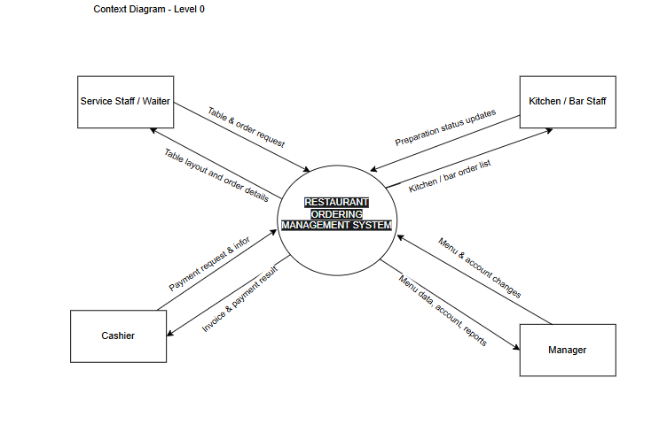
Hình 3.1 Level 0 1

3.2 1-level DFD
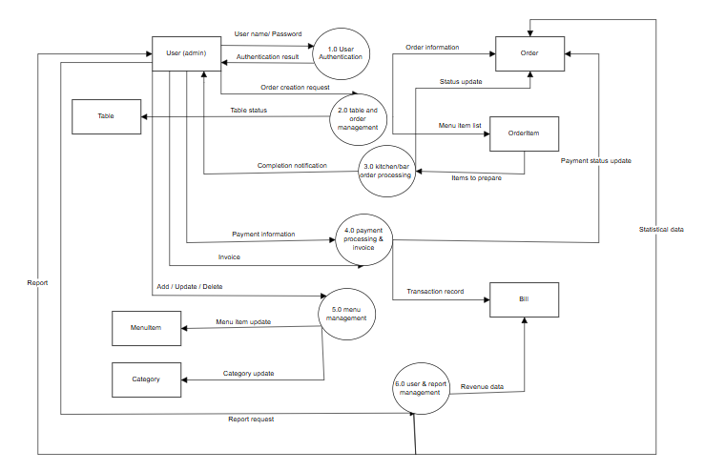
Hình 3.2 Level 1 1

IV. USE-CASE DIAGRAMS

4.1. Overview diagram
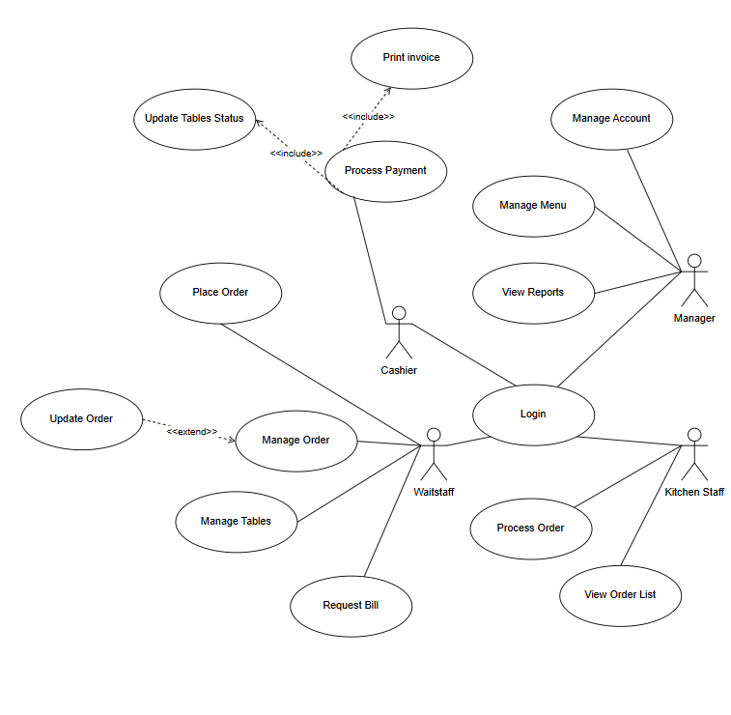
Hình 4 Overview Diagram 1

4.1.1. List of System Actors

No | Actor | Description
1 | Manager
  The restaurant manager, responsible for managing the menu, employee accounts, and viewing reports.
2 | Wait Staff | Staff members who directly serve customers, manage tables, and place orders.
3 | Kitchen Staff | Kitchen and bar staff responsible for preparing food and beverages.
4 | Cashier | Staff responsible for processing payments and printing invoices.
Bảng 4.1.1 List of System Actors 1

4.1.2. Actor – Use Case Table
Actor | Use Case | Description
Manager | Login | Log in to the system with manager privileges.
Manager | Manage Menu | Add, edit, delete, and update the status of food and beverage items.
Manager | Manage Account
  Create, update, lock, or unlock employee accounts.
Manager | View reports | View revenue reports and statistics of best-selling and least-selling items.
Wait Staff | Login | Log in to the system with waitstaff privileges.
Wait Staff | Manage Tables | View the table layout and update table status.
Wait Staff | Place Order | Create a new order for a table.
Wait Staff | Manage Order | Add items, update quantities, and add notes to an order.
Wait Staff | Update Order(extend) | Update an existing order when customers request additional items.
Wait Staff | Request Bill | Request payment for a table.
d | Login | Log in to the system with cashier privileges.
d | Process Payment | Process payments using cash or electronic transfer.
d | Print Invoice(include) | Print an invoice for the customer.
d | Update Tables Status(include) | Update the table status to “Available” after payment.
Kitchen Staff | Login | Log in to the system.
Kitchen Staff | View Order List
  View the list of orders that need to be prepared.
Kitchen Staff | Process Order | Mark items as completed after preparation
Bảng 4.1.2 Actor-UseCase 1

4.2 USE CASE SPECIFICATIONS

4.2.1. Use-case Login

4.2.1.1. Summary
- This use case allows a user (Manager, Waitstaff, Cashier, Kitchen Staff) to log in to the Restaurant Order Management System by entering a valid username and password. After successful login, the user is allowed to access system functions according to their role.

4.2.1.2. Flow of Events
- Main Flow of Events
  - The user opens the login page.
  - The user enters a username and password.
  - The user submits the login request.
  - The system verifies the entered credentials against the database.
  - If the credentials are valid, the system logs the user in and redirects them to the dashboard corresponding to their role.
- Alternative Flows
  - Invalid username or password:
    - At step 4, if the username or password is incorrect, the system displays an error message.
    - The user is asked to re-enter the login information.
- Inactive account:
  - At step 4, if the user account is deactivated, the system denies access and displays a notification.

4.2.1.3. Special Requirements
- User passwords must be stored securely using a strong one-way hashing algorithm.
- Login information must not be displayed in plain text.
- Only authenticated users are allowed to access internal system functions.

4.2.1.4. Preconditions
- The user has a registered account.
- The system is available.

4.2.1.5. Postconditions
- Successful login: User is authenticated and granted role-based access.
- Failed login: User remains unauthenticated.

4.2.1.6. Extension Points
● None.

4.2.2 Use-Case Manage Account

4.2.2.1 Summary
This use case allows the Manager to create, edit, lock/unlock staff accounts and assign roles, supporting “User Login and Staff Account Management”.​

4.2.2.2 Flow of Events
- Main Flow of Events
  - The Manager selects "Manage Accounts".
  - The system lists staff accounts with username, full name, role, status.
  - The Manager chooses to create, edit, or lock/unlock an account.
  - For create: the Manager enters username, temporary password, full name, selects a role (service staff, cashier, kitchen, bar, manager), and saves.
  - For edit: the Manager updates fields such as role or full name, possibly resetting the password.
  - For lock/unlock: the Manager changes the account status between active and locked.
  - The system updates account data and refreshes the list.
- Alternative Flows – Duplicate username
  - If the username already exists, the system prevents saving and asks for a different username.

4.2.2.3 Special Requirements
- Role-based restrictions must be enforced as described in the functional requirements (service staff: tables & orders; cashier: payments; kitchen/bar: preparation tasks; manager: reports, menu, accounts).​

4.2.2.4 Preconditions
- The Manager is logged in.

4.2.2.5 Postconditions
- Staff accounts and roles are updated and affect subsequent logins and permissions.

4.2.2.6 Extension Points
- None.

4.2.3. Use-case Manage Tables

4.2.3.1. Summary
- Allows Waitstaff to monitor and update dining table statuses in real time.

4.2.3.2. Flow of Events
- Main Flow of Events
  - Select “Manage Tables”.
  - System displays floor plan with table status.
  - Select a table.
  - Update table status.
  - System saves changes.
  - Floor plan is refreshed.
- Alternative Flows
  - View Table Details:
    - Waitstaff views current order without updating status.

4.2.3.3. Special Requirements
- Interface must be visual and intuitive.

4.2.3.4. Preconditions
- Waitstaff is logged in.

4.2.3.5. Postconditions
- Table status is synchronized system-wide.

4.2.3.6. Extension Points
- None.

4.2.4. Use-case Place Order

4.2.4.1. Summary
- Allows Waitstaff to create new orders and send them to the kitchen.

4.2.4.2. Flow of Events
- Main Flow of Events
  - Select “Place Order” or table.
  - System shows menu.
  - Select food items.
  - Specify quantity and notes.
  - Items added to cart.
  - Confirm order.
  - System saves order.
  - Table marked “Occupied”.
  - Kitchen notified.
- Alternative Flows
  - Item out of stock: System shows notification.
  - Cancel order: System discards unsaved data.

4.2.4.3. Special Requirements
- Real-time inventory update.
- Low latency order transmission.

4.2.4.4. Preconditions
- Waitstaff logged in.
- Table is available or occupied.

4.2.4.5. Postconditions
- Order and OrderItems created.
- Kitchen receives order.

4.2.4.6. Inclusion Points
- Use-case Manage Tables.
- Use-case Manage Order.

4.2.5. Use-case Manage Order

4.2.5.1. Summary
- Allows modification of active unpaid orders.

4.2.5.2. Flow of Events
- Main Flow of Events
  - Select active table.
  - View order details.
  - Add or update items.
  - System recalculates total.
  - Changes saved and sent to kitchen.
- Alternative Flows
- Remove Item:
- Confirmation required before removal.

4.2.5.3. Special Requirements
- Only unpaid orders can be edited.

4.2.5.4. Preconditions
- Active order exists.

4.2.5.5. Postconditions
- Order details updated.

4.2.5.6. Extension Points
- None.

4.2.6 Use-Case View Order List (Kitchen/Bar)

4.2.6.1 Summary
This use case allows Kitchen and Bar Staff to view the list of items that need to be prepared, based on current orders. It implements “Kitchen and Bar Support”.​

4.2.6.2 Flow of Events
- Main Flow of Events
  - The Kitchen/Bar Staff opens the Kitchen/Bar screen.
  - The system displays all pending items grouped or tagged by table or order, including item name, quantity, and notes.
  - The list is sorted by time so older items appear first.
  - The screen auto-refreshes to show new items when Service Staff place or update orders.

4.2.6.3 Special Requirements
- The Kitchen/Bar screen must auto-refresh or push updates without requiring manual reload.

4.2.6.4 Preconditions
- Kitchen or Bar Staff is logged in.
- There are active orders with items to be prepared.

4.2.6.5 Postconditions
- Staff has a clear and current list of items to prepare.

4.2.6.6 Extension Points
- Extended by Process Order (Kitchen).

4.2.7. Use-case Request Bill

4.2.7.1. Summary
- Allows Waitstaff to generate a provisional bill.

4.2.7.2. Flow of Events
- Main Flow of Events
  - Customer requests bill.
  - Select table → Request Bill.
  - System generates preview bill.
  - Order marked “Bill Requested”.
  - Bill presented to customer.

4.2.7.3. Special Requirements
- Detailed item and tax breakdown.

4.2.7.4. Preconditions
- Order is active and unpaid.

4.2.7.5. Postconditions
- Bill generated.

4.2.7.6. Extension Points
- None.

4.2.8. Use-case Process Payment

4.2.8.1. Summary
- Allows Cashier to finalize payment and close orders.

4.2.8.2. Flow of Events
- Main Flow of Events
  - Select “Process Payment”.
  - View pending orders.
  - Select order.
  - Display final bill.
  - Choose payment method.
  - Enter received amount.
  - Validate payment.
  - Order marked “Paid”.
  - Receipt printed.
- Alternative Flows
  - Payment declined: Request another method.

4.2.8.3. Special Requirements
- Accurate calculations.
- Orders locked after payment.

4.2.8.4. Preconditions
- Order exists and unpaid.
- Cashier logged in.

4.2.8.5. Postconditions
- Bill saved.
- Revenue updated.

4.2.8.6. Extension Points
- Use-case Print Invoice.

4.2.9. Use-case Process Order (Kitchen)

4.2.9.1. Summary
- Allows Kitchen Staff to process food items.

4.2.9.2. Flow of Events
- Main Flow of Events
  - View kitchen display.
  - Orders sorted by time.
  - Update status to “Cooking”.
  - Update status to “Ready”.
  - Notify Waitstaff.
- Alternative Flows
  - Out of ingredients: Item marked cancelled.

4.2.9.3. Special Requirements
- Auto-refresh display.

4.2.9.4. Preconditions
- Kitchen Staff logged in.

4.2.9.5. Postconditions
- Item status updated.

4.2.9.6. Extension Points
- None.

4.2.10. Use-case Manage Menu

4.2.10.1. Summary
- Allows Manager to manage menu items.

4.2.10.2. Flow of Events
- Main Flow of Events
  - Select “Manage Menu”.
  - View products.
  - Add/Edit/Delete items.
  - Enter details.
  - Save changes.
- Alternative Flows
  - Delete failed: Item in active order.

4.2.10.3. Special Requirements
- Manager-only access.

4.2.10.4. Preconditions
- Manager logged in.

4.2.10.5. Postconditions
- Menu updated.

4.2.10.6. Extension Points
- None.

4.2.11. Use-case View Reports

4.2.11.1. Summary
- Allows Manager to view business reports.

4.2.11.2. Flow of Events
- Main Flow of Events
  - Select “View Reports”.
  - System retrieves data.
  - Display charts/tables.
  - Filter by date.
- Alternative Flows
  - No data found: Notification displayed.

4.2.11.3. Special Requirements
- Export to PDF/Excel.

4.2.11.4. Preconditions
- Manager logged in.

4.2.11.5. Postconditions
- Reports displayed.

4.2.11.6. Extension Points
- None.

4.2.12. Use-Case Update Order

4.2.12.1 Summary
This use case allows Service Staff to update an existing order during the dining process by adding new items, changing quantities, or removing items that have not yet been prepared. It directly maps to the second bullet in “Ordering and Table Order Management”.​

4.2.12.2 Flow of Events
- Main Flow of Events
  - From Manage Order, the Service Staff selects "Update Order".
  - The system shows the list of items in the order including quantity, note, and preparation status.
  - The Service Staff adds new items from the menu (only Available items), entering quantity and notes.
  - The Service Staff updates quantities or notes for items that are still Pending.
  - The Service Staff removes items that are still Pending (not yet prepared).
  - The system recalculates the temporary total.
  - The Service Staff confirms the changes.
  - The system saves changes to order items and updates the order’s temporary total.
  - New or canceled items are reflected on the Kitchen/Bar screen where applicable.
- Alternative Flows – Item already prepared
  - If the Service Staff tries to modify or remove an item that is Cooking or Completed, the system disallows the change and shows a message.

4.2.12.3 Special Requirements
- Business rules must ensure only non-prepared items can be removed or edited.

4.2.12.4 Preconditions
- The Service Staff is logged in.
- An active order exists for the table.

4.2.12.5 Postconditions
- The order contents and temporary total are updated.
- Kitchen/Bar are informed about added or canceled items.

4.2.12.6 Extension Points
- None.

4.2.13 Use-Case Update Tables Status

4.2.13.1 Summary
This use case describes how the system automatically updates table status in response to key events in the order lifecycle, reflecting the rules described in “Table Management and Table Status” and “Payment and Invoice Printing”.​

4.2.13.2 Flow of Events
- Main Flow of Events
  - When a new order is created for a table that is Available, the system automatically sets the table status to Serving.
  - When an order moves to “Waiting for Payment”, the system can set the table status accordingly (if this status is displayed).
  - When an order is Paid, the system changes the table status back to Available for the next customers.

4.2.13.3 Special Requirements
- Automatic status updates must be consistent and instantly visible in all table views.

4.2.13.4 Preconditions
- Related use cases (Place Order, Process Payment) have been executed.

4.2.13.5 Postconditions
- Table statuses correctly mirror the order lifecycle.

4.2.13.6 Inclusion Points
- Included in Place Order, Request Bill, and Process Payment.

4.2.14 Use-Case Print Invoice

4.2.14.1 Summary
This use case generates and prints an invoice for a paid order so the customer receives a receipt. It is part of “Payment and Invoice Printing”.​

4.2.14.2 Flow of Events
- Main Flow of Events
  - The use case is triggered from Process Payment after successful payment.
  - The system retrieves order and payment information.
  - The system formats invoice details: restaurant info, table, order items, quantities, unit prices, total amount, payment method, time, cashier.
  - The system sends the invoice to a printer or displays a printable format.
- Alternative Flows – Printing error
  - If printing fails, the system shows an error and allows the Cashier to retry.

4.2.14.3 Special Requirements
- Invoice layout must be clear and consistent with restaurant standards.

4.2.14.4 Preconditions
- Payment for the order has been recorded successfully.

4.2.14.5 Postconditions
- The invoice is printed or ready to be printed.

4.2.14.6 Extension Points
- None.

V. CLASS DIAGRAM
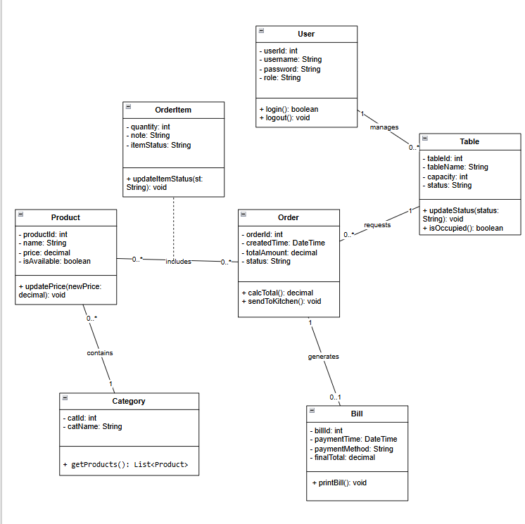
Hình 5 CLass Diagram 1

VI. DATA MODEL
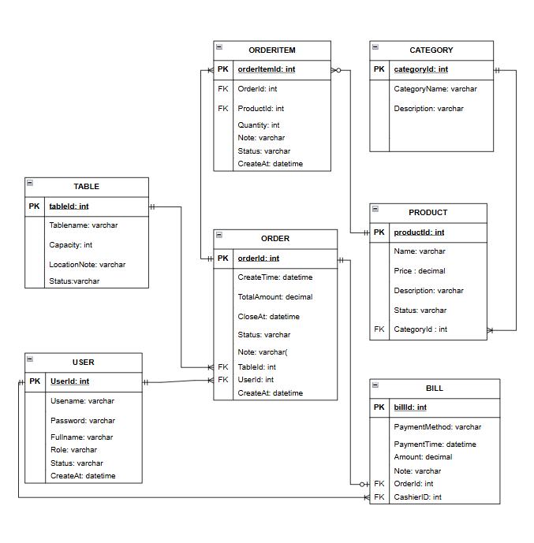
Hình 6.1 Data Model 1

VII. INTERFACE DESIGN DESCRIPTION
The system features an intuitive and minimalist interface designed to streamline restaurant operations—from guest arrival and ordering to kitchen preparation. It ensures seamless, real-time communication between front-of-house staff and the kitchen.

7.1. Login Screen
Consists of the brand logo, input fields (username, password), and the primary action button. It authenticates user identity and grants system access based on specific roles.
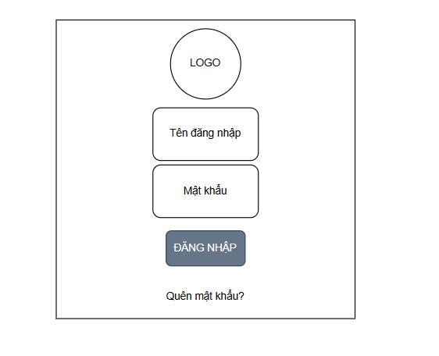
Hình 7.1 Login Screen 1

7.2. Table Map Management Screen
Visually displays the restaurant's table list along with specific statuses (Available, Occupied, Cleaning required). It helps staff monitor guest density and quickly coordinate seating arrangements.
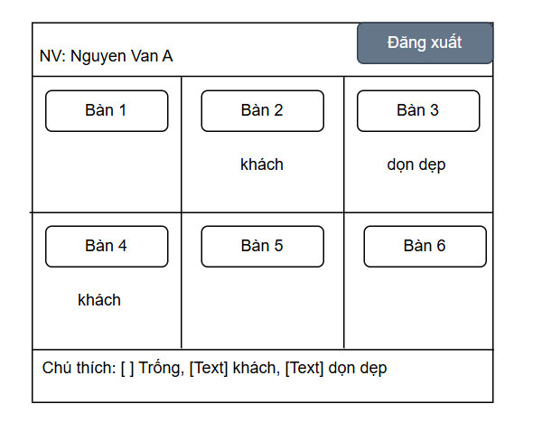
Hình 7.2 Table Map Management Screen 1

7.3. Ordering Screen
Divided into two main sections: the Menu Catalog and the Table Order Details with total costs. It allows for quick item selection, quantity adjustment, and direct data transmission to the kitchen.
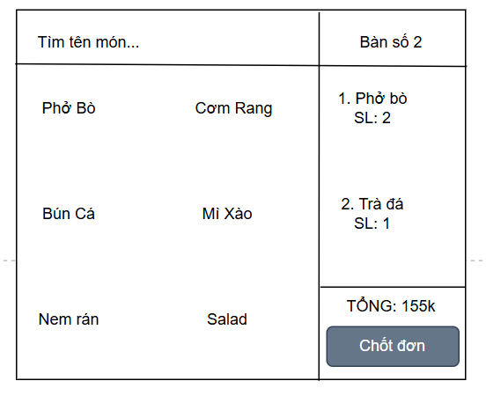
Hình 7.3 Ordering Screen 1

7.4. Pending List Screen (Kitchen/Bar)
Displays food tickets awaiting processing by table number. Kitchen staff accept preparation requests and confirm completion to notify the servers.
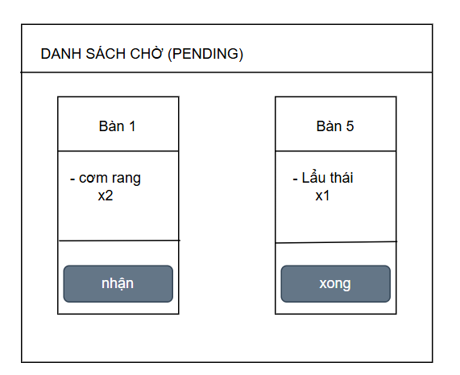
Hình 7.4 Pending List Screen 1

